附件 3
申请办法
Port Visa Application Procedure in Shanghai
参加我公司展览会的海外观众或展商，可申请办理口岸签证。
Foreign visitors / exhibitors who come to China for attendance of our exhibition can apply for the Port Visa.
1、请填写《口岸签证申请人信息登记表》并与护照扫描件一并提交我司。
Hand in the completed 《Foreign Nationals Port Visa Information Form》, together with the scan copy of the applicant’s passport to the event organizer.
2、我司核对材料后提交上海市出入境管理局审核，一般于5日内提出审核意见，经核准同意的，由上海出入境管理局向我司发放《外国人口岸签证受理单》，并由我公司通过电邮或传真将《外国人口岸签证受理单》转交拟入境外国人。
The organizer will collect the applications and preliminarily check the information before submit to the Exit-Entry Administration of Shanghai Public Security Bureau for approval. Usually, the result will be known within 5 working days. Once the application is approved, the Exit-Entry Administration of Shanghai Public Security Bureau will issue the 《Port Visa Notification》 and inform the organizer to forward it to the foreign national applicant via email or fax.
3、外国人持上海口岸签发的《外国人口岸签证受理单》及护照，须由上海口岸入境，出境口岸不限，入境时须填写《外国人口岸签证申请表》并附1张2寸彩色证件照，交纳签证所需费用（非对等国家单次口岸签证费用为168元人民币，对等国家按国家间相互协议确定。）。
《Port Visa Notification》 only offer permission of entry from the Shanghai ports to China. (It will be invalid if from ports of the other cities in China. In other words, a foreign national can be denied entry upon arrival if his or her initial destination in China is NOT Shanghai.）
When arrive at the Shanghai ports, a foreign national is required to fill in 《Port Visa application form》 on the counter and provide:
- his or her approved 《Port Visa Notification》
- passport
- 1 piece of color photo (2 inches, bare-headed, full face, bust photograph taken
within 6 months)
- and prepare for the visa charges (Cash, RMB168 for Non-equivalent countries. The charges to equivalent countries will follow the agreement signed by both countries).

咨询电话 Consultative Tel：+86-21-33392236
联系人 Contact: 朱智予 Sylvia Zhui
Email: Sylviazy.Zhu@ubmsinoexpo.com

注意：
外国人下飞机后，按照机场内的“VISA”指引牌至口岸签证柜台办理口岸签证，再至边检通道处办理入境手续。
Tips:
After getting off a plane, please follow the sign “VISA” to the assigned counter for your Port Visa, then go ahead to Boarder Control Entry for Immigration service.
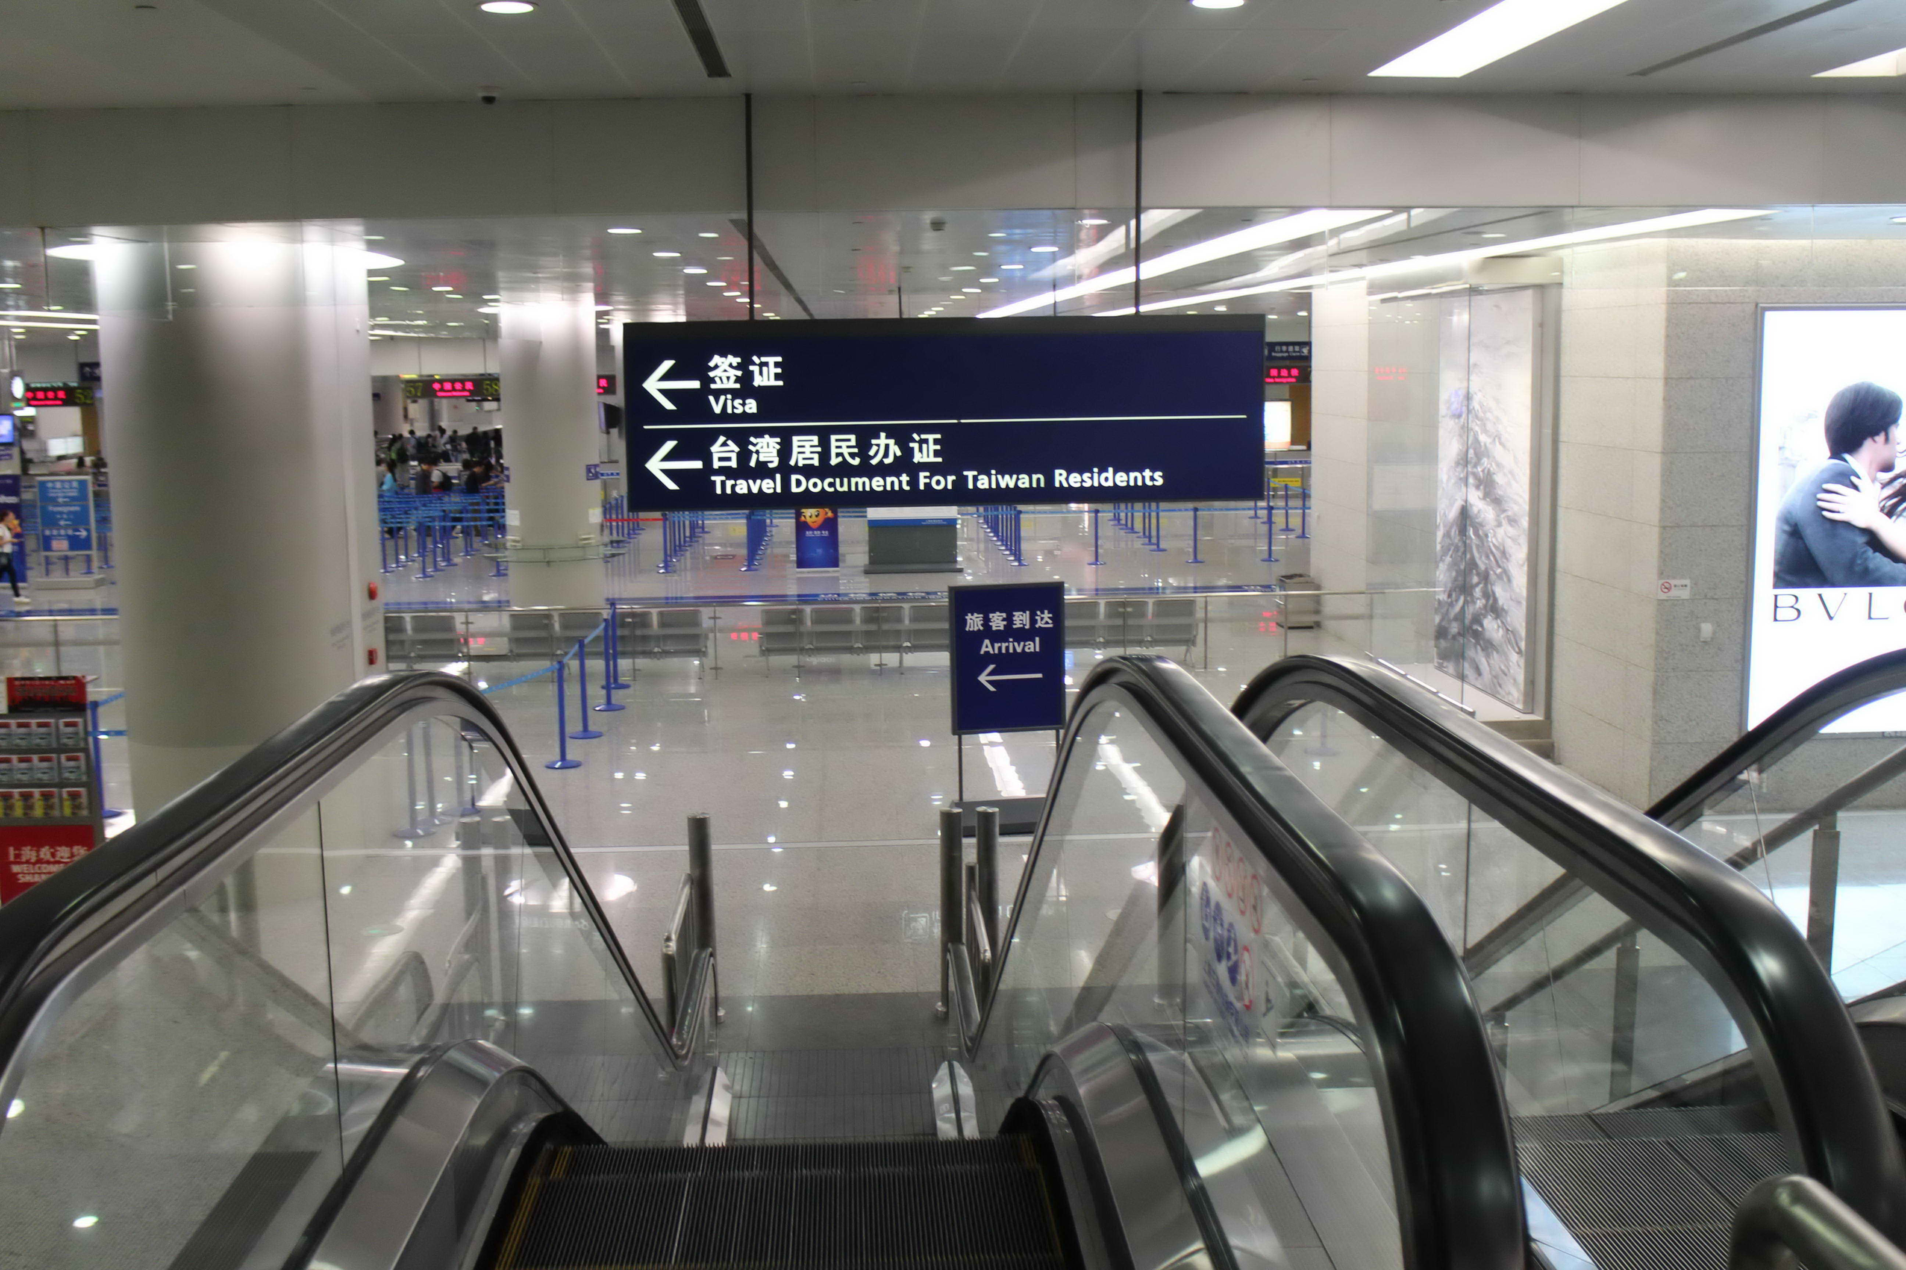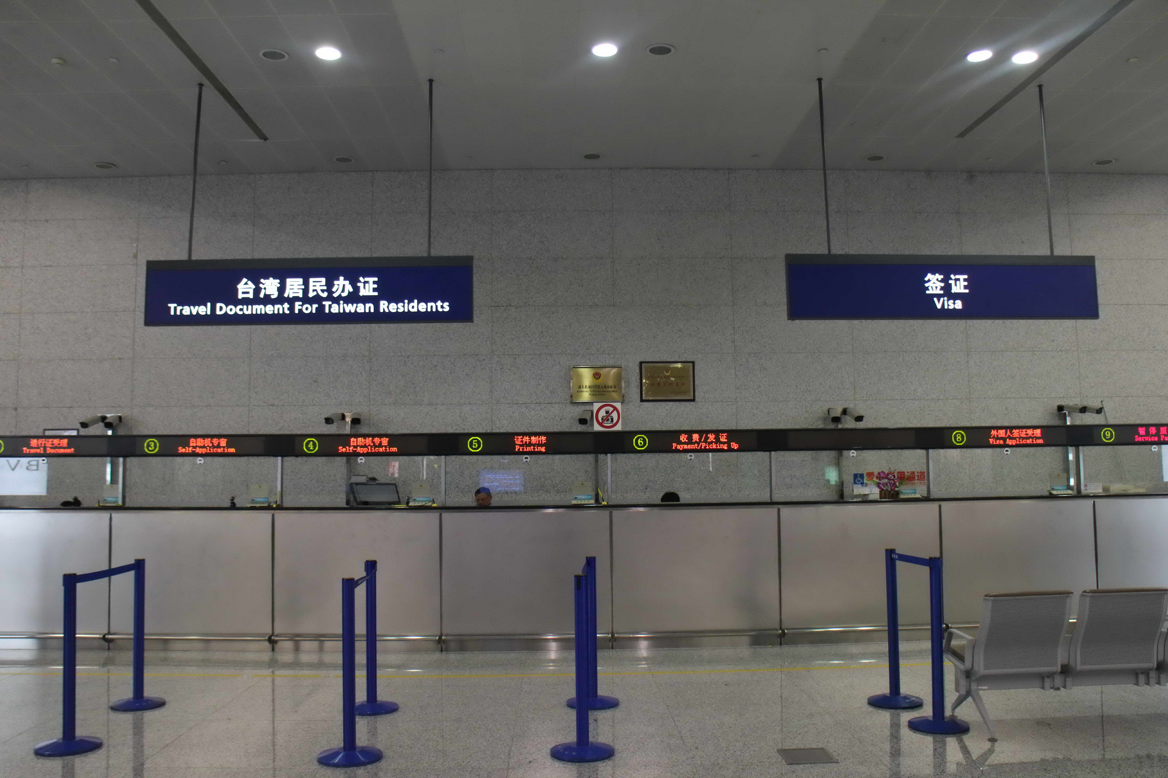
Foreign Nationals Port Visa Information Form
《口岸签证申请人信息登记表》

No. | Surname | Given Name | Date of Birth | Sex | Nationality | Passport Valid until | Passport No. | Company | Proposed Address in China | Telephone | Event Name | Date of Entry
1
2
3
4
38
5
6
7
8

常见问答
Q & A
问：是不是境内所有的单位都可以为其邀请的外国人在网上申请口岸签证？
答：只有在上海市出入境管理局登记备案并获授权的单位，才可以向上海市出入境管理局申请外国人口岸签证；为提高我公司服务水平，方便外国人参加我公司举办的展会，经上海市公安局出入境管理局审核，目前我公司(上海博华国际展览有限公司)已获得为外国人申请办理上海口岸签证的授权。
Q: Can all the domestic corporations apply the Port Visa for their invited foreign guests?
A: No, this policy is NOT open to all the domestic corporations. Only those who have registered at the Exit-Entry Administration of Shanghai Public Security Bureau and have been authorized have the right to submit the application of Foreign Nationals Port Visa. To provide our customer service to a higher level and to make convenience for foreign buyers to attend the exhibition, we (Shanghai UBM Sinoexpo Int’l Exhibition Co., Ltd.) have applied to the Exit-Entry Administration of Shanghai Public Security Bureau for the permission and already got the official approval to be qualified for this policy.
问：口岸签证与中国境外使领馆办理的商务签证有什么区别？
答：口岸签证办理的申请材料及手续都比通过中国境外使领馆办理商务签证更加简化，办理时间也大大缩短，因此通过口岸签证入境更加便利。
Q: What’s the difference between Port Visa and Business Visa?
A: As to the Port Visa, the application materials and procedures are simplified. Moreover, the processing time of Port Visa is much shorter than that of the regular Business Visa. In this regard, Port Visa is regarded more convenient as a certificate to China.
问：哪些外国人不能申请口岸签证？
答：
(1) 《中华人民共和国出境入境管理法》第二十一条规定的人员；
(2) 持外交、公务、官员护照等非因私普通护照的人员；
(3) 按规定应到我驻外使领馆办理签证国家的公民；
(4) 隐瞒真实身份，提供假情况、假材料的人员；
(5) 其他原因不宜批准来华的人员。
Q: Under which circumstances CANNOT a foreign national apply for Port Visa?
A: Under any of the following circumstances, the visa shall not be issued to foreigners:
(1) In line with Article 21 of the《Personnel People's Republic of China Immigration Control Act》
(2) With Diplomatic / Service / Business / Official / Special Passport
* Only Ordinary Passport is applicable here for application of Foreign Nationals Port Visa
(3) The one who in prescript should be apply for the visa at the Embassies and the Consulates
(4) Resort to fraudulent acts in visa application
(5) Other circumstances in which visa authorities consider a visa should not be issued

问：《外国人口岸签证受理单》有什么用途？
答：《外国人口岸签证受理单》有两种用途：一是便于申请人搭乘相应的交通工具顺利到达口岸；二是申请人抵达口岸后作为申请办理签证的重要材料。
Q: What is the use of the 《Port Visa Notification》?
A: The 《Port Visa Notification》 serves the following usefulness: (1) To notify the applicant his or her correct port of entry; (2) As the crucial certificate to apply visa at the ports of entry.
问：持有核准的《外国人口岸签证受理单》的外国人在到达口岸办理签证时需履行哪些手续？
答：
（1）提供中国政府承认的外国政府或者国际组织办法的有效普通护照和其他国际旅行证件；
（2）递交填写完整并签名的《外国人口岸签证申请表》 （抵达上海口岸后填写）
（3）交近期2英寸半身正面免冠彩色照片一张；
（4）交验已核准的《外国人口岸签证受理单》；
（5）按规定支付签证费。
Q: What are the procedures required to perform when foreign guests arrive at the port of entry with the approved 《Port Visa Notification》?
A:
(1) Provide valid personal passport and other international travel documents acknowledged by the Government or the International Organizations
(2) Complete the 《Port Visa application form》 upon arrival in Shanghai port
(3) 1 piece of color photo (2 inches, bare-headed, full face, bust photograph taken within 6 months)
(4) the approved 《Port Visa Notification》
(5) Pay the visa charges accordingly ( Visa Charges )
问：口岸签证的有效入境次数和有效期是怎样的？
答：口岸签证的有效入境次数为一次入境有效，入境后可停留时间不超过30日。
Q: What about the Valid Entry Number and Expiration Date?
A: Port Visa provides Single Entry within 5 days Valid Expiration Date and duration of stay not exceeding 30 days.
问：核准的《外国人口岸签证受理单》是否有有效期限？
答：自审核同意之日起一个月有效，超过一个月未到口岸办理签证的，即为失效。
Q: Does the approved 《Port Visa Notification》 have expiration date?
A: The 《Port Visa Notification》 is valid for one month from the date of issue. If the foreign national applicant fail to make it in due time, his or her《Foreign Nationals Port Visa Notification》 will be automatically conducted as invalid.

